Word association  Give children two sets of words which are related to each other. Children discuss associations they notice between the words. If some words are not strongly associated, this is worthwhile to talk about too.  For example:  to sneak to leap to discover  treasure secret fence  In this example, the words to sneak and secret may not be considered very strongly associated, so discuss what might be a better choice. | Word association 2  Give the children three words and three associated sentences to match them to. Explain verbally, or in writing, their reasons for association.  For example:  to sneak to leap to discover  - Quickly, we ran away.  - We tried not to be seen.  - She hoped she would find something special. | Word Association 3  Using a graphical organiser such as a spider diagram, consider when you might encounter a word in different contexts.  For example:  In the example below, the word ‘line’ is thought of in the context of different school subjects, but you might also consider other contexts such as places and times.  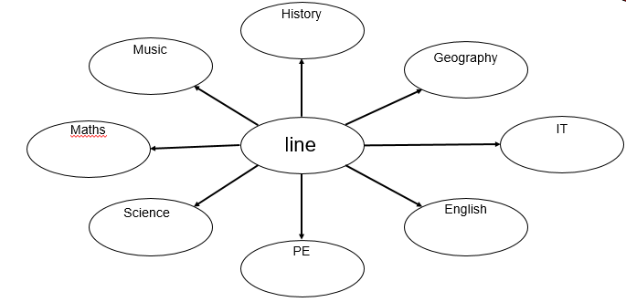
Word association 4  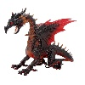  Simply list all of the sensible associations or known facts to do with a given word. The sharing of collective knowledge helps all children to improve their understanding.  mythical  wings  The Hobbit  magical  breathes fire  scales  dragon | Word Webs  Have children list words with the same prefixes, roots or suffixes as a given word.  leaping  sleeping  playing  reading  writing  jumps  jumped  jumper  jumping | Prefixes and suffixes  Children must use given prefixes and suffixes to build words, deciding which combinations are correct and which aren’t.  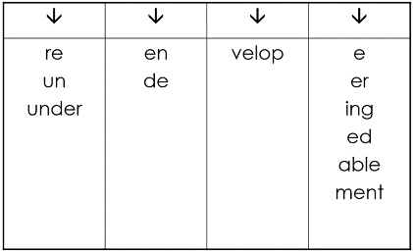
Word families  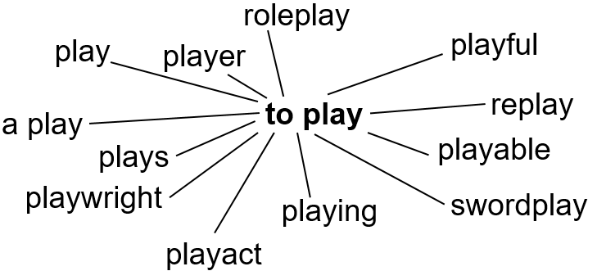  Using a root word, get the class to think of suffixes and prefixes that can be added, along with different verbs, nouns, compound nouns and any other associated words. | Can you…?  plod skip tiptoe  Children act out verbs given to them (works well with adverbs for a given verb, too), with teachers coaching them to improve their example by giving examples of when these verbs are performed and how better to act, thereby supporting children’s understanding of a focused and accurate definition. | What am I thinking of?  Describe something to your class, using pre-planned ambitious vocabulary. They must guess what you’re thinking of.  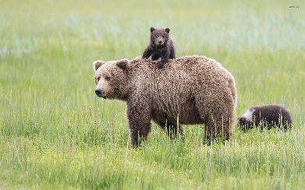
What’s wrong?  Show children a sentence or sentences with incorrectly chosen words and ask them to make a better choice. This helps teach children precise use of language, clarifies the definition of words and their accurate use.  For example:  The plant growed really tall.  (incorrect verb)  Her toy car was massive.  (probably too strong a word – large or big might be a better choice) | Word storms / maps  Choose a setting or character and then ask children to list words to describe it They can use adjectives, nouns and verbs – direct children to one type of word for greater focus. Teachers can then offer better alternatives for children’s choices, and coach children in their meanings.  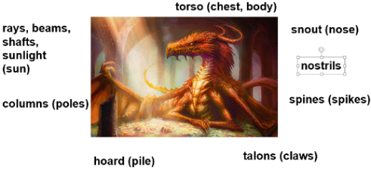 | Sentence builders  Having used word maps (see previous box), especially focussed ones, teach children to build these up into sentences using grids such as the one below.  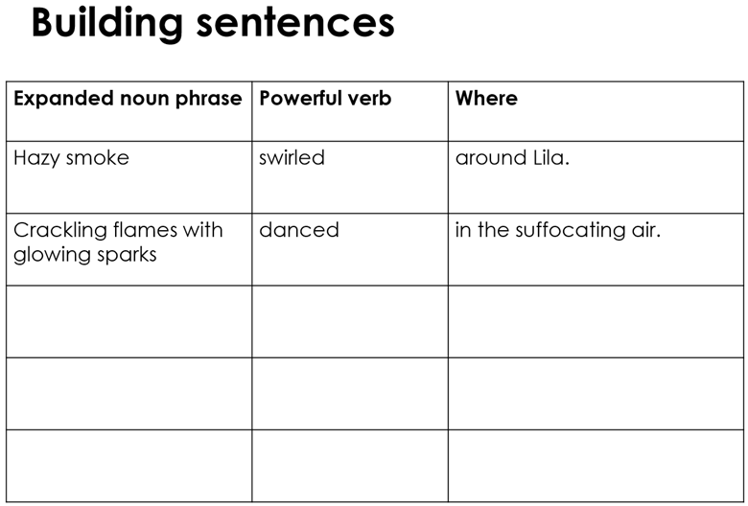
Word studies  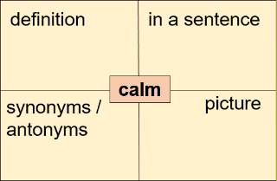  Children fill in boxes about a given word to consilidate their understanding.  Other ideas (see other boxes):  - word family  - good for / not good for  - word association  - shades of meaning  deep dive | Word studies 2  By considering syllables, words in the same word class, and even words that end in the same way, this version of the classic word study can reinforce spelling patterns and grammar links.  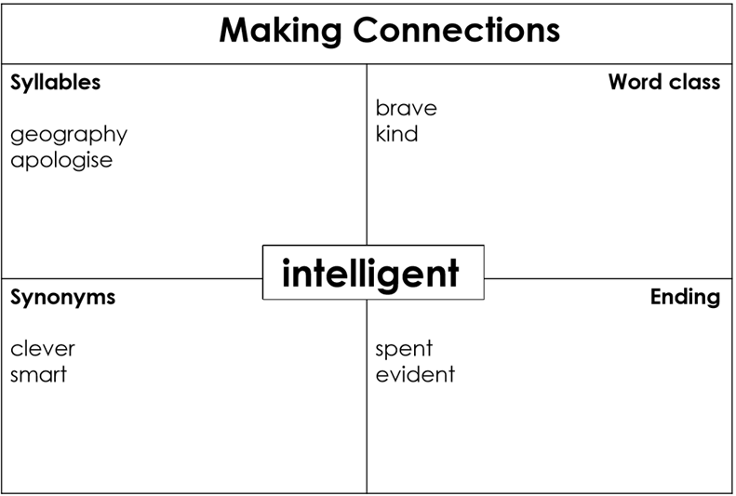 | Rich scripting  Delve into idioms, proverbs and compound words with this idea which focus children on the richness of a word or concept. Teachers could model how including several references to a single idea within writing can help build a stronger overall impression for readers.  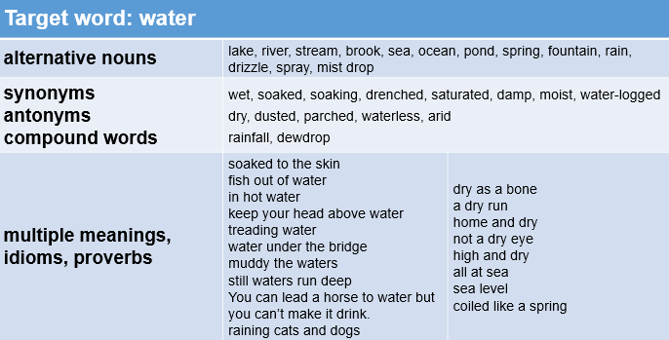
Deep dive  Explore how many different ways children can think of to use a word. Adults may well know more variations or contexts where it’s appropriate.  For example:  How many ways can you think of to use the word…  slip  slip on the floor, a slip of paper, slipped your mind, slip through the door, slippery, a slip of a girl, slip into something comfortable, a clay slip to join ceramics, wear a slip, etc. | Questions  Ask children to think of examples to answer questions involving the vocabulary you’re focusing on. This helps to narrow the definition in their mind, as well as giving opportunities for contextualising their understanding of the word.  For example:  - When have you ignored someone or something?  - Why might you grasp something?  - Think of three things you could have a portion of…  - What might a caring person say to someone who is nervous? | When would you?  Children must think of as many different situations when they would do something.  For example:  gulp  Situations might include:  - gulp when you’re thirsty  - gulp down food when you’re hungry  - gulp when you’re scared  - gulp air when you’ve been underwater too long
What am I?  Children each have a Post-it with a word on stuck to their forehead. Tell children if they have an adjective/noun/verb/etc and perhaps give them a context for the use of their word.  For example:  You all have adverbs.  Or…  You all have nouns that are found in the forest.  They must then ask questions of each other to figure out what their word is. | Cloze sentences  Give children sentences with missing words – they must select the right word to fill the gaps, explaining their choice.  For example:  The __________ monster _________over me.  mighty / gentle stomped / tip-toed  Its _________, deadly claws stretched out towards me.  big / huge / grab  I hoped I could _______ , but I didn’t know how!  escape / cry / grasp | Sorting  Give children a bank of words to sort. There might be several ways to do this, all of which may be valid. The more words, the more options and the harder it will be.  For example:  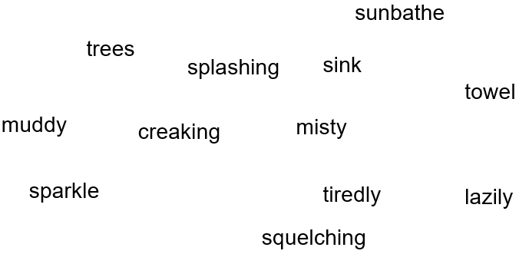  Children may sort these into nervous mood words and calm ones.
Change the mood  Choose a paragraph with a clear mood. Children must replace words, changing sentence structures as little as possible, to completely change the mood of the text.  Ideas for clear moods:  - a terrifying monster  - a grand prince  - an eerie setting  - a calm beach  - a busy street | Word building  Give children a short root word to increase in length by adding prefixes and suffixes.  For example:  win kind  wind kindly  windy unkind  winded winding unkindly kindness unkindness  unkindliness | Applause applause  Give children three words and ask them which they would rather be described as (or rather do) and clap more or less or not at all when one is pointed at to show their enthusiasm for the word choice. Discuss why.  For example:  lonely thoughtful sneaky
Would you rather?  plod sprint tiptoe  Decide which you rather do and why. Discuss.  This really helps distinguish between the subtle differences between similar words. It helps to act these out and to give situations where these would be appropriate and when they wouldn’t. | Figurative language analysis  Use a simple table to discuss the literal and figurative meaning behind language.  For example:  “The look he gave me hurt.”  literal meaning figurative meaning  His eyes caused me pain. The way he looked at me hurt my feelings and made me sad. | Hyponyms  Hyponyms are words which are more specific examples of a more general word. Flow diagrams help children remember words and make sense of them because of the groupings. Exploring words in this way helps children to make precise, informative choices.  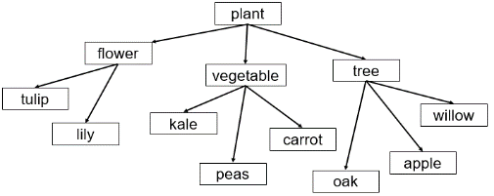
Phrase maps  Use a spider diagram to explore words and phrases associated with a chosen word.  For example:  light  lighthouse, moonlight, spotlight, in the spotlight, light of my life, lighten up, shed some light on things, light at the end of the tunnel  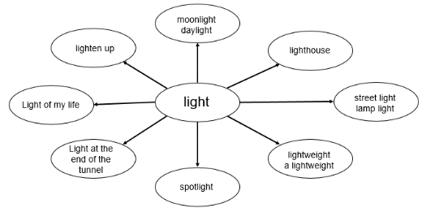 | Taboo  Agree on a word with the class that one child will describe and define. Send one child out while you agree with the rest on what words are likely to be used in the explanation. List these on the board and ask the child to return, not looking at the listed words. They must try and describe and explain the word without using the words in the list.  Consider listing:  - synonyms,  - antonyms  - context words | Labelling / naming using contexts  Especially useful in EYFS, name and label things children can see in every day contexts.  For example:  - coat – button, popper, press stud, zip, pocket  - dinner – food, plate, knife, fork, spoon, bowl, dish, glass, beaker, cup  - water tray – splash, pour, drip, trickle, wave, slosh, plop  Other ideas:  - Use story language too  Try phrases as well as words

Shades of meaning - words  Give children a variety of words about a theme, from one extreme to another. They must order them on a spectrum.  For example:  blistering boiling sweltering hot warm tepid cool chilly cold bitter freezing  Other ideas:  - Give children some blank cards for their own ideas.  - First, ask children what the words have in common. | Shades of meanings – phrases  Give children a variety of words about a theme, from one extreme to another. They must order them on a spectrum.  For example:  hit the roof  blow my top  fly off the handle  see red  hot under the collar  got my back up  Other ideas:  - Give children some blank cards for their own ideas.  First, ask children what the words have in common. | Linking back to a text  Use targeted vocabulary to ask children to find examples from a text.  For example:  - Find three times when pebbles have been important in the story.  - Find two places a character had to discover someone or something.  - Find three words that make the reader think that the sight was terrifying.
Hidden letter synonyms/antonyms  Give children a table of synonyms and antonyms with missing letters for children to complete.  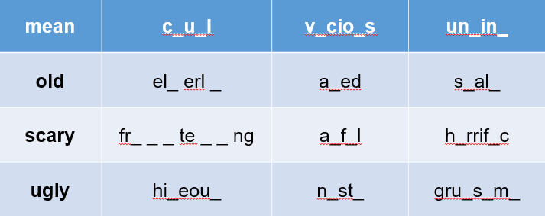  This is a good opportunity to reinforce spelling patterns and rules. | Teach your spellings  - Teach how to spell words on your lists, but also what they mean using child friendly definitions. Explore how to use them using the ideas in this document. | Sentence stems  Ask children to use a sentence stem to practise their use of specific words.  For example:  - The terrifying creature had ______ ________and _______ ________.  - I discovered a _________ in a __________.

