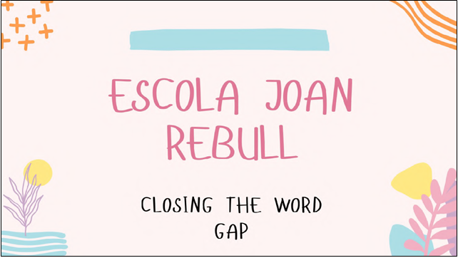
Closing the Word Gap
2019-1-UK01-KA229-061373_1
Study Visit #3 : Escola Joan Rebull - Reus, Spain
3rd to 5th November 2021
The objectives of the project are to:
• analyse and share existing strategies and resources for improving oracy to close the gap between disadvantaged learners and their peers
• identify common areas of strength and priorities for development
• undertake study visits to partner schools to investigate the policies and practice in the context of those schools
• use the outcomes of the study visits to improve provision and practice in identifying and addressing oracy disadvantage
• produce a report on the outcomes of each study visit, sets of case studies and recommendations for school policy
• disseminate the outcomes widely

The outputs of the project will be:
• An online platform hosting the project website, reports and case studies
• A set of case studies
• An impact report incorporating recommendations for school policy
• A dissemination strategy including examples of best practice, online materials and events in 4 countries

Wednesday 3rd November 2021
Welcome and introductions
We were warmly welcomed by the project team and the school management, as we were given more in-depth information about the school. Interestingly, while teaching is conducted in Catalan, learning resources can be also in other languages like Spanish, French or English. Only 50% of pupils speak Catalan at home, so it is the other 50% pupils’ main chance of learning and practicing Catalan. Various activities across the school are used to promote multilingualism, including weather displays in English, months and seasons in Catalan, Spanish and English.
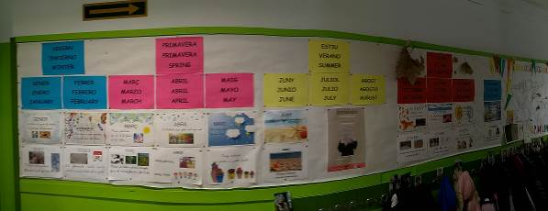

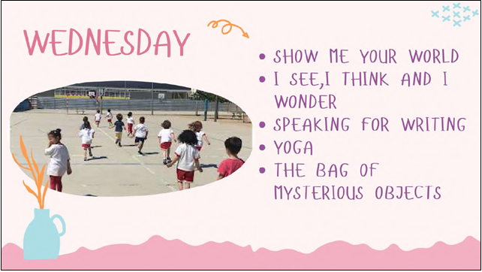

Observed Activity 1: Show me your world
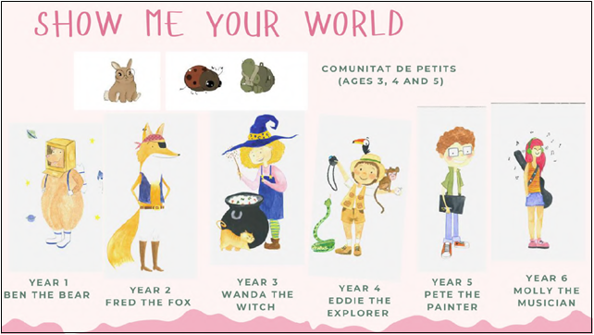

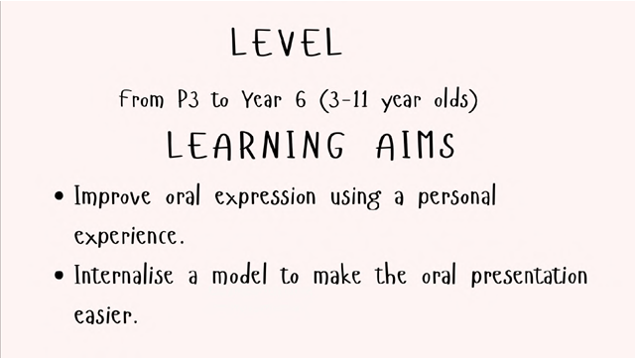
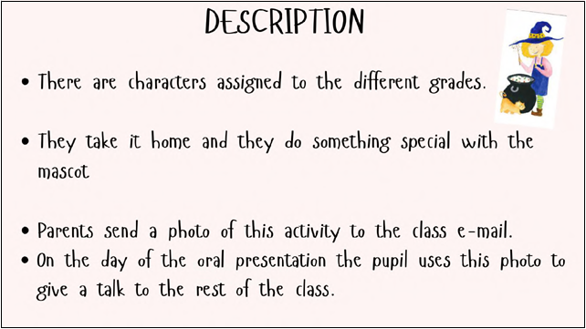
The pupils then use the questions in the star for their presentation as well as the tips in the following picture.
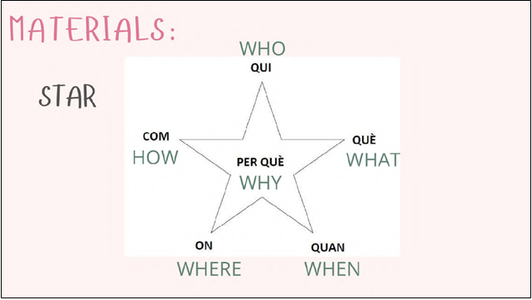
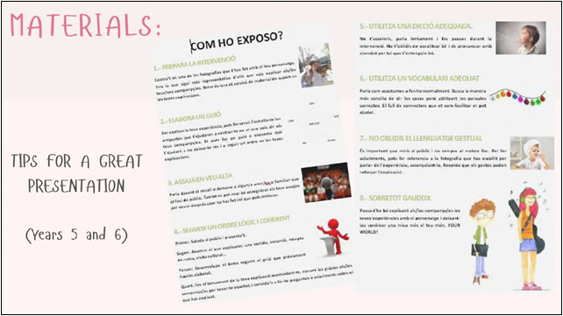
The pupils are assessed in a constructive manner by their peers and by their teacher using the rubrics bellow
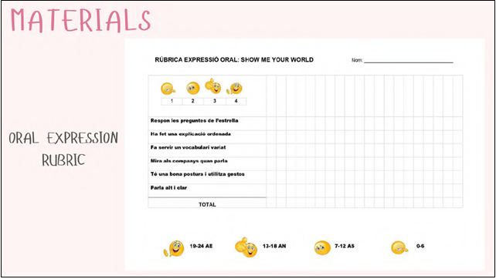
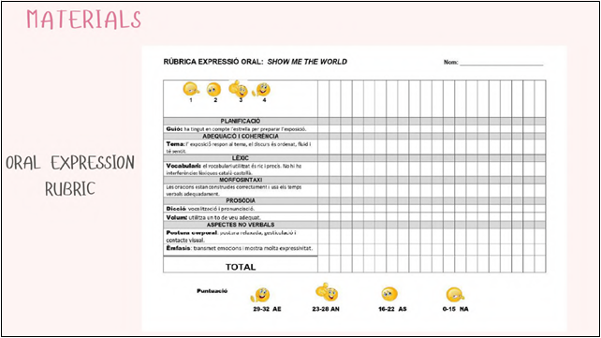

Observed Activity 2: I see, I think, I wonder
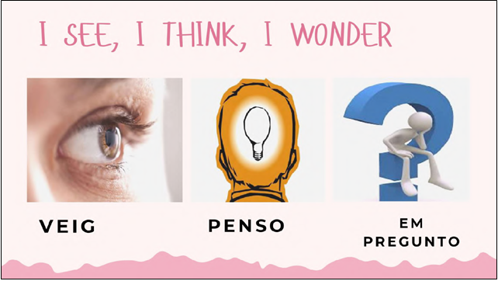
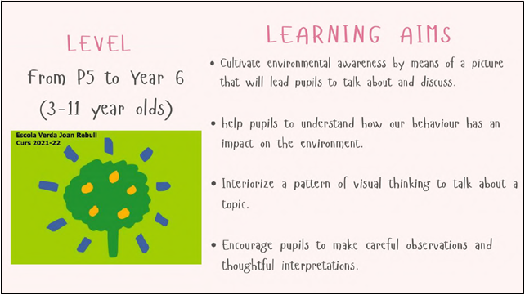
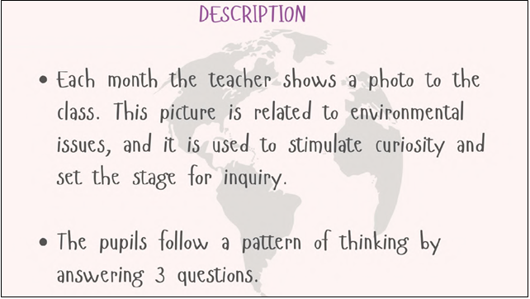
The pupils describe what they see, then they describe their thoughts and finally they wonder about other things related to the picture.
As this activity is done across all years using the same picture, the best contributions are put on display at the entrance hall of the school


Observed Activity 3: Speaking for writing
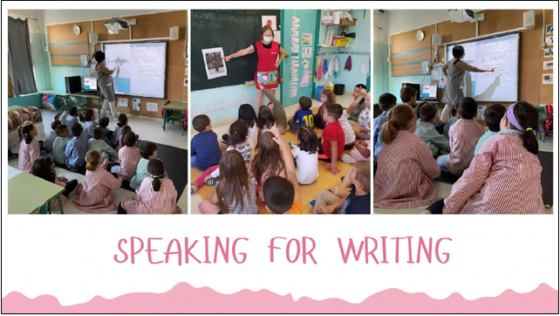
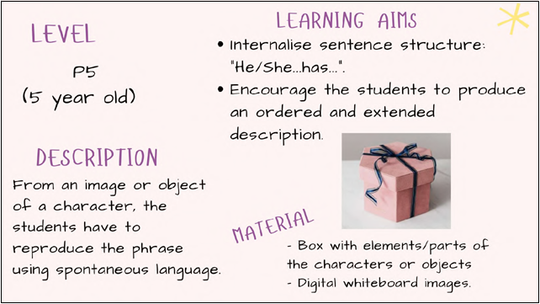
The children first discuss a topic, in this case the season of chestnuts – Castanyada, and then they write the words that had been discussed. There is an online tool to facilitate the activity. The training resources came from the government, two teachers self-trained and then cascaded the method to their colleagues.

Observed Activity 4: Yoga
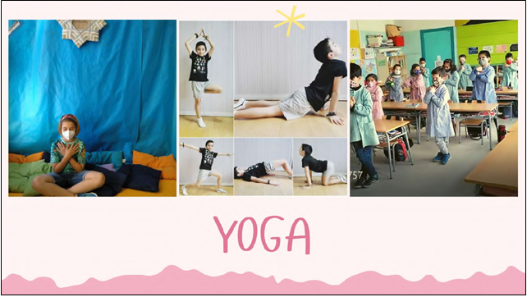
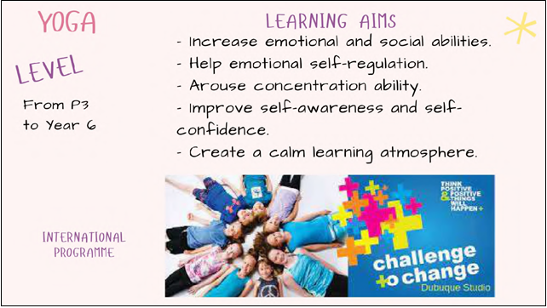
Yoga is used a as a way to calm down, focus and learn the importance of well-being and taking care of their own mind. Teachers have followed a course about yoga for children encouraging self-regulation and mindfulness. After initiation by the teacher, sessions can be led by the children, rather than by the teacher.
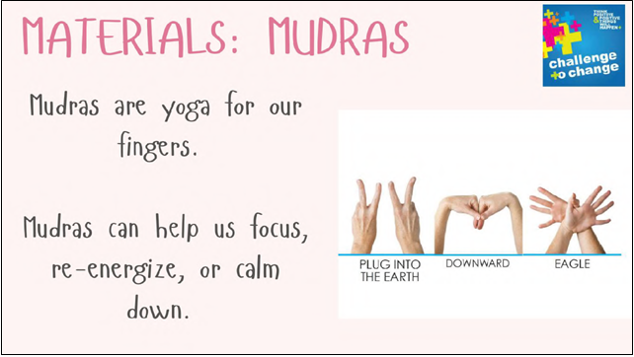
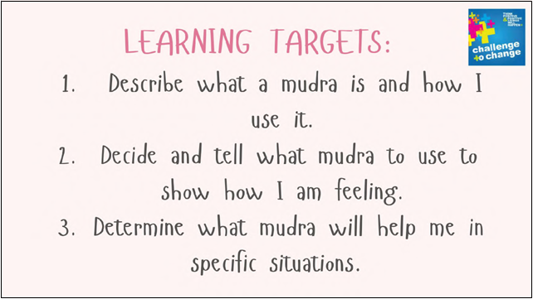
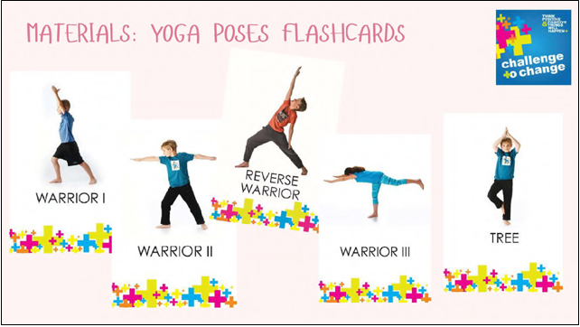
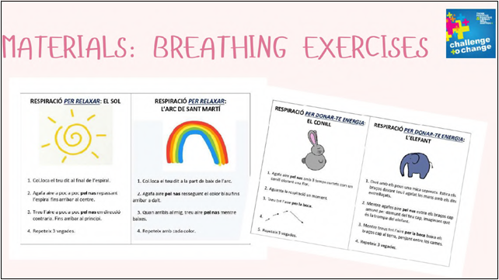
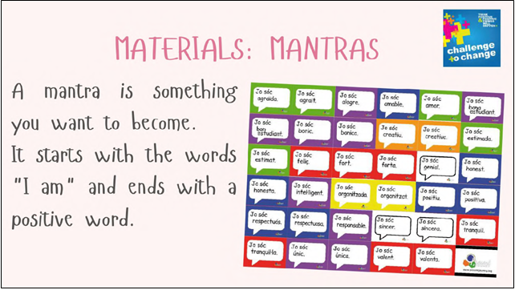
Observed Activity 5: The bag of mysterious objects
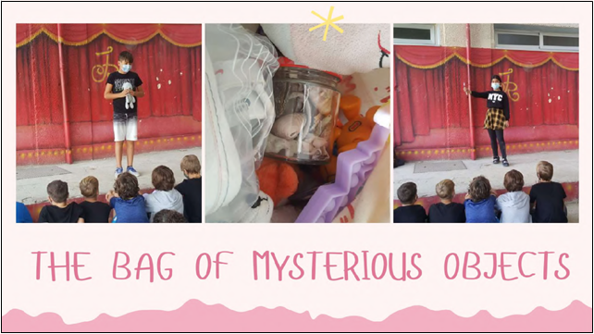
This activity encourages public speaking in front of a gathered audience. This 3-minute activity is then evaluated by the teaches, the speaker themselves and their peers.
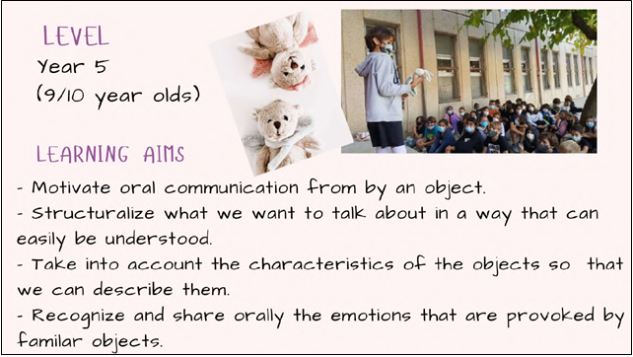
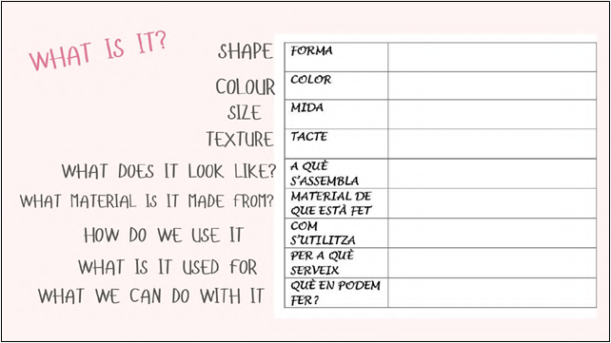

Thursday 4th November 2021
On the second day, the focus was on pre-school education and on the various approaches to supporting children with SEND.
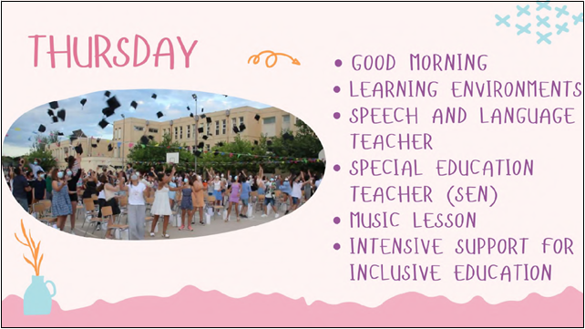

Observed Activity 6: Morning activities at pre-school level
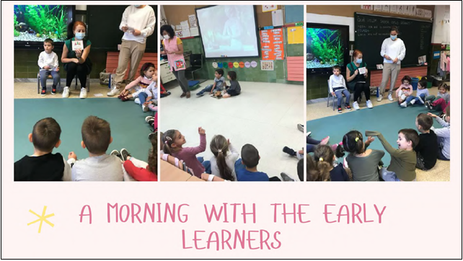
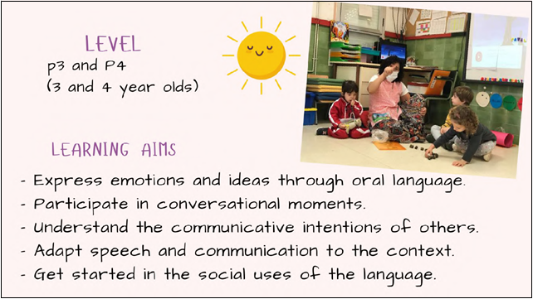
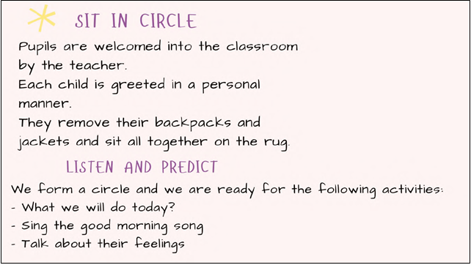
It was most interesting to observe that children were encouraged to describe their emotions on the morning whether through words or at least through pictures. It helps the children be more aware of their own feelings and how they affect their surroundings. It helps well as the teacher who can better support and understand the pupils’ behaviour on the day.

Observed Activity 7: Learning environments at pre-school level
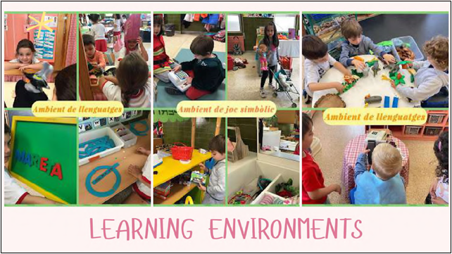
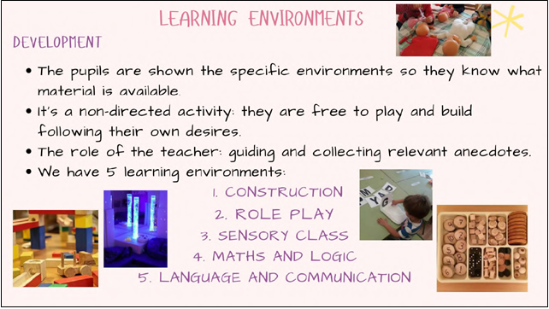
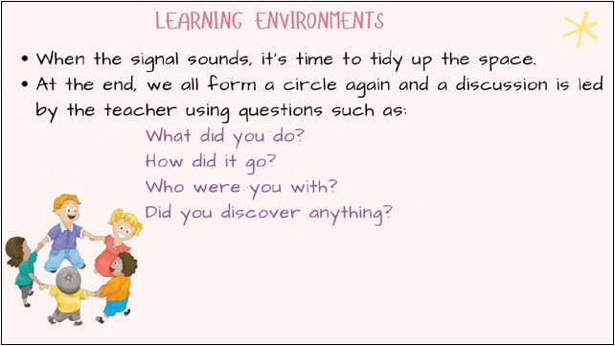
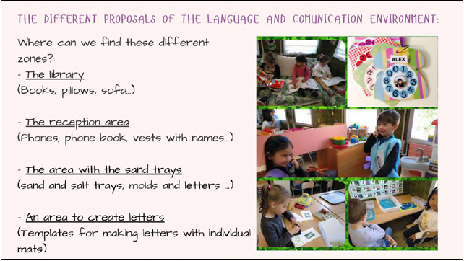
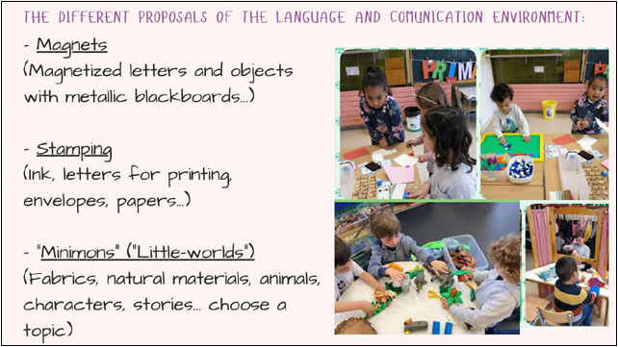
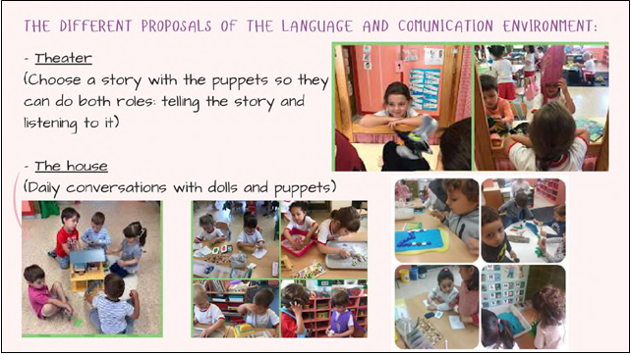

Observed Activities 8: Addressing Special Educational Needs
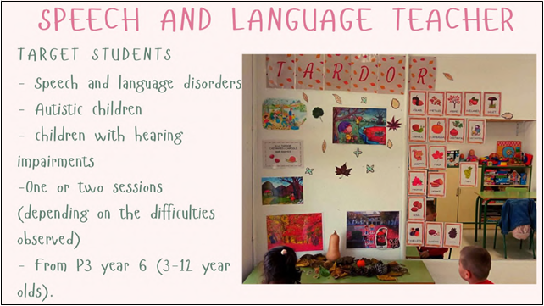
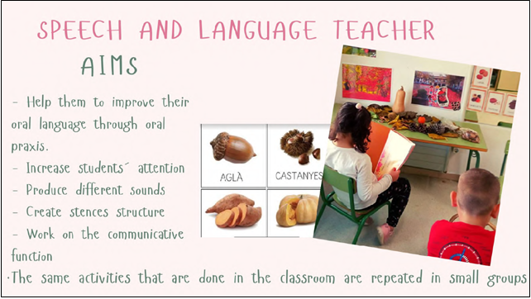
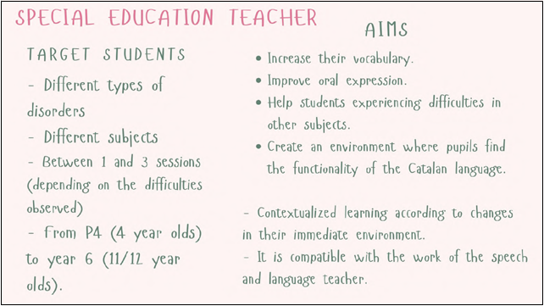
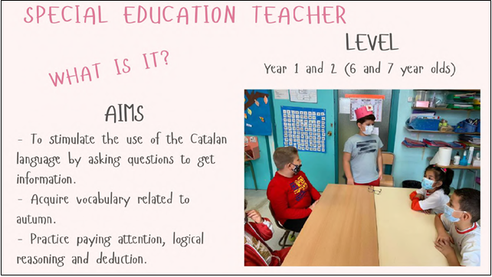
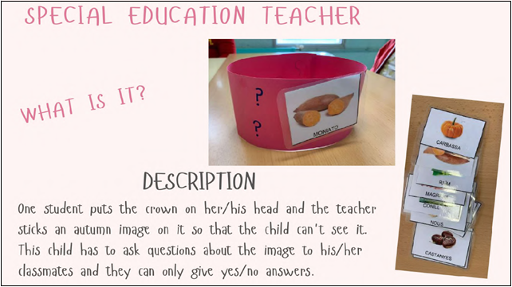
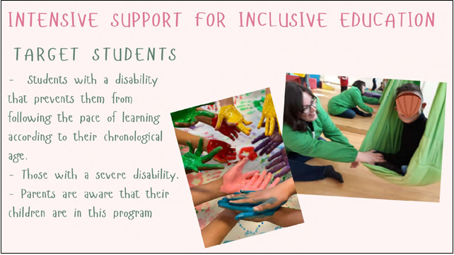
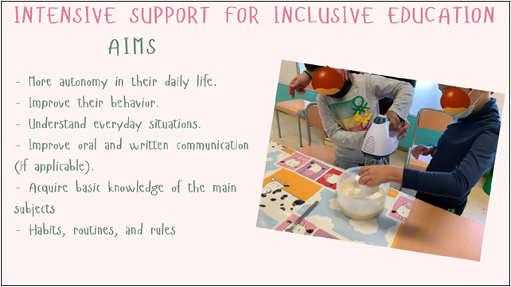
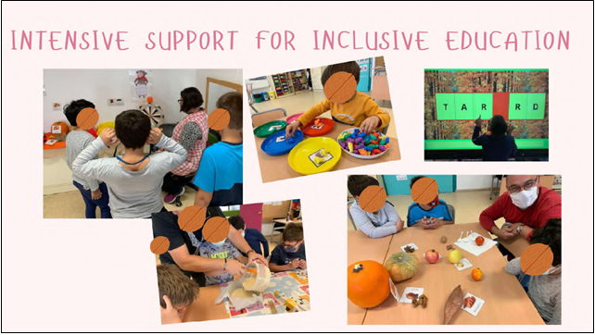
We were able to observe:
- 3 to 4 hours of support a week fr specific non-severe needs like non-native speakers
- Severely affected pupils with SEN go to daily 2-hour sessions of Intensive support for Inclusive Education, but they send most of the time in class with the other children.
- There is a Psychomotricity class available where music is associated with movement
- Speech therapy is conducted by a qualified speech therapist working with 2 children at a time
- It is the SEN teacher who grades the main subjects of Maths, Catalan and Spanish.
- Inclusiveness is also fostered among the other children.

Friday 5th November 2021
On the third day, the focus was on whole school activities focusing on art and reading.
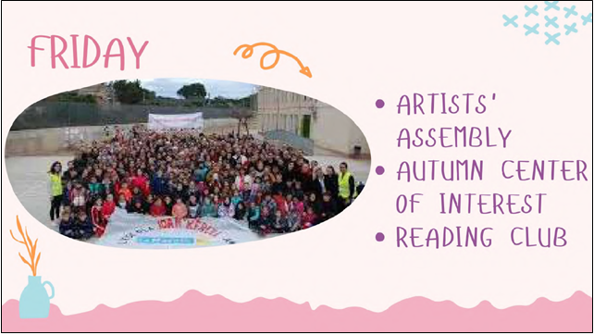

Observed Activity 9: Autumn Centre of Interest
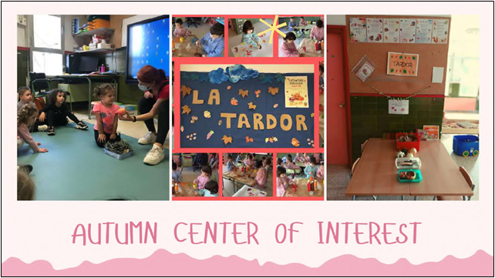
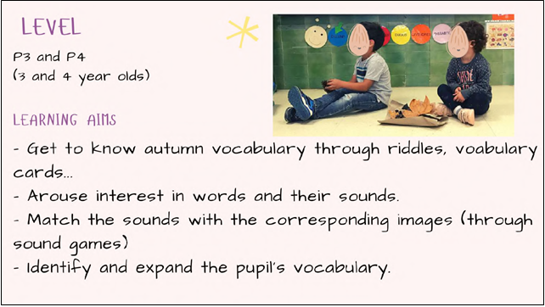
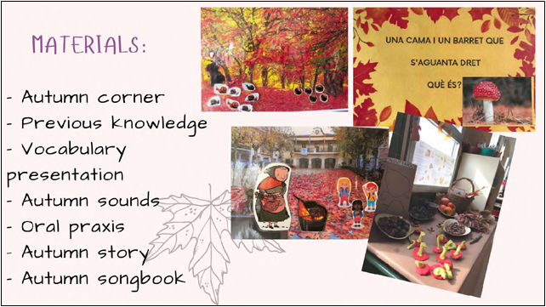
We observed a specific activity with 3to4-year-olds where early awareness of letters and sounds is developed through pictures: First the picture is covered, and the children guess the sounds based on the letters of the word represented by the picture. Then the picture is uncovered.

Observed Activity 10: Artists’ Assembly
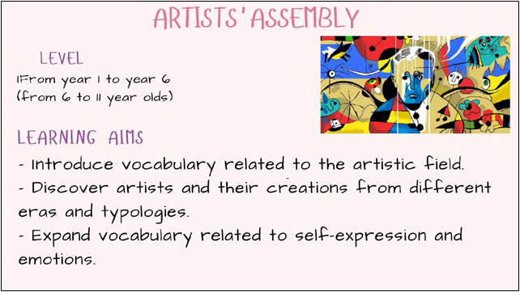
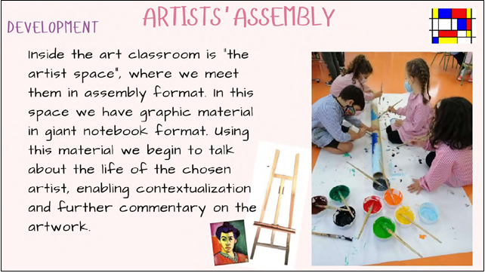
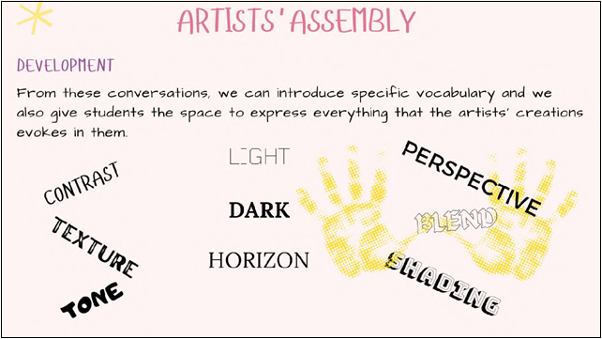
We observed an activity where children are first presented with a variety of activities in the different areas of the classroom and then they choose where they want to work and create.
Observed Activity 11: Reading Club

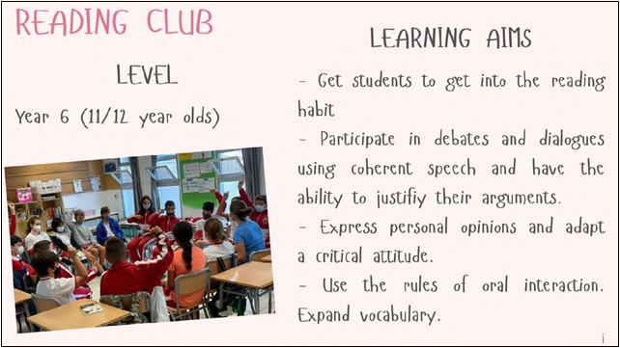
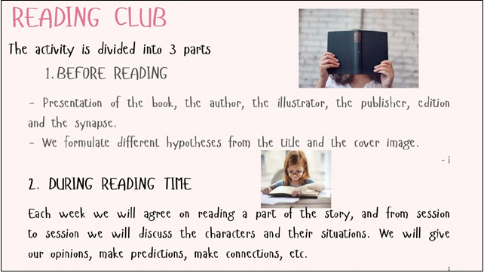
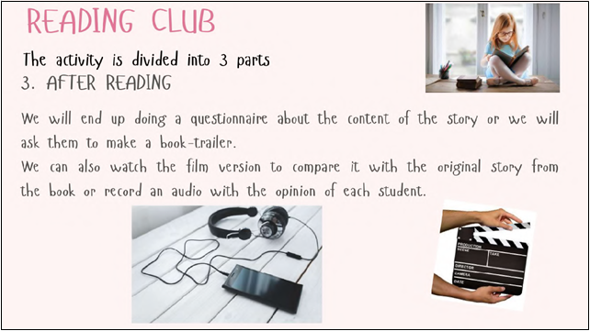
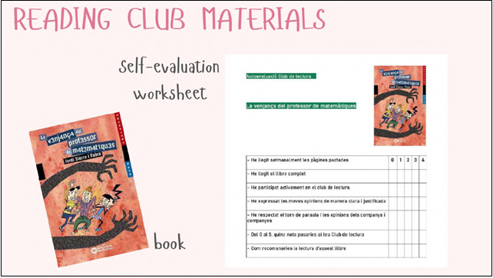

General observation:
All partners were impressed by the organisation and the content of the training event and also grateful for the opportunity to learn in observation and discussion with the colleagues from the partner countries.
Overall it was an amazingly well organised workshop where plenty of observation led to fruitful discussions of similarities and differences, and namely great inspiration for additional oracy-supporting activities in the partner schools.
The participants in the activity observed the strategies used at the school in Reus. They were able to see how the 'Closing the Gap' methodology has been adapted to the Spanish context. The workshop discussion and the common drafting of the case study allowed the participants to gain the skills for follow-up activities on return to school. The teachers had an opportunity to consider whether what they have observed can apply to their own methodology in the classroom. On return they will cascade the results of their activities to colleagues and also lead on the joint follow-up activities.

All partners contribute to this table considering their national and local contexts.
CHALLENGES | STRATEGIES | EXPECTED IMPACT
Using the different topics addressed in the study visit, please, identify any related challenges faced by your school / group of schools | What strategies can you adopt in order to tackle the challenges described in the first column? | What is the expected impact of a proposed strategy and how will it be measured?

